臺北市政府資訊局 新聞稿
發布機關:臺北市政府資訊局
發布科室:綜合企劃組
張貼日:2018/3/29
聯絡人:高淑芸
聯絡電話:02-27208889分機8550、0922-866-336

Taipei City Creates Trial Field for Smart Innovation Industry
Self-Driving Vehicle Demo Catches Public Attention

The 2018 Smart City Summit & Expo comes to an end on March 30th. "Taipei Pavilion" spotlights 7 topics, including "smart traffic", "smart public housing ", "smart medical care", "smart startup", "smart education", "smart ecological community" and "smart security", along with self-driving vehicle exhibition outdoors. The showcase exhibits a full range of smart city solutions to domestic and foreign visitors. Among them, the self-driving car has attracted public attention, drawing many visitors to experience the intelligent transportation technology.

Taipei City Government is working on building a smart city through the approach of public-private partnerships (PPP), which won much applause from civil society and industry players. As both a platform and test bed, Taipei can be the provider of a variety of smart solutions to set an example for the construction of cities across the world. On March 13th this year, Taipei launched the Beitou-Shilin Science and Technology Park to be the autonomous vehicle testing ground. This is the first-ever in Taiwan, combining IoV (Internet of Vehicles), autonomous vehicles and intelligent infrastructure. It also displayed related testing results and mapping outcomes by research and development institutes in the “Smart Startup Zone”.

During the exhibition, the outdoor demonstration of autonomous self-driving vehicles near exit No. 2 of the MRT Nangang Exhibition Hall station featured an array of the latest transportation devices, including 7Starlake’s self-driving minibuses, the PEV (a persuasive electric self-driving tricycle developed by “City Science” project team in MIT Media Lab in collaboration with National Taipei University of Technology), and NTU auto-driving SUV developed by National Taiwan University (NTU) autonomous electric vehicle team and iAuto technology. The showcase provided the public with a glimpse of what the technology of autonomous self-driving vehicles can bring.

Exhibition Information: https://en.smartcity.org.tw

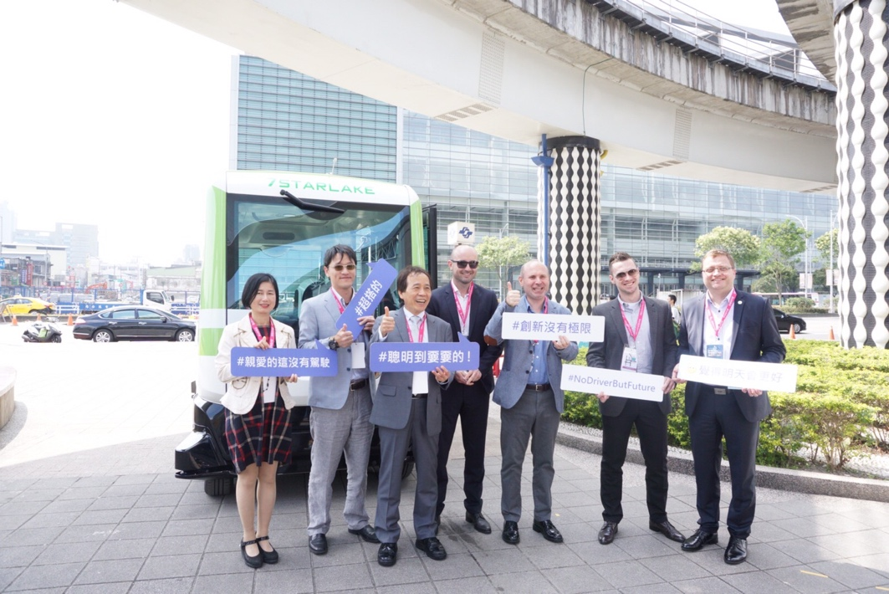
The self-driving minibus was exhibited publicly at the outdoor demonstration area (near exit No. 2 of the MRT Nangang Exhibition Hall station), attracting visiting mayors and representatives from overseas cities. The delegates has an opportunity to experience the potentials of self-driving vehicles.

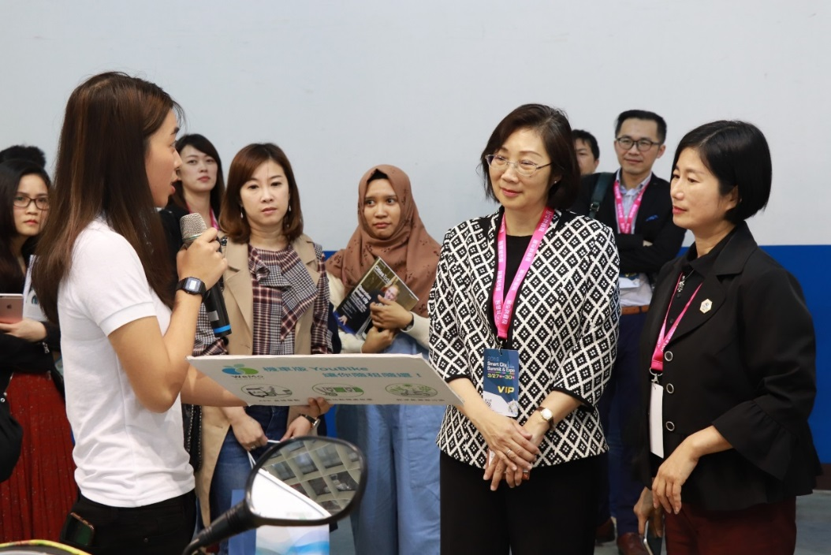
The Deputy Minister of Science and Technology, Mr. Zou Yuhan (second left), accompanied by the Chief Secretary Chen Huimin of the Department of Information Technology, visited the Taipei Pavilion and attended a briefing on “Smart Traffic Zone”

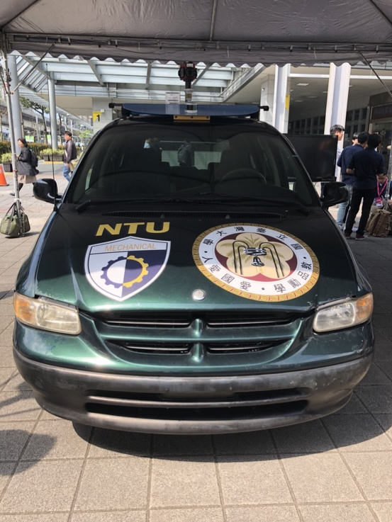
The NTU auto-driving SUV – developed by National Taiwan University (NTU) autonomous electric vehicle team and iAuto technology

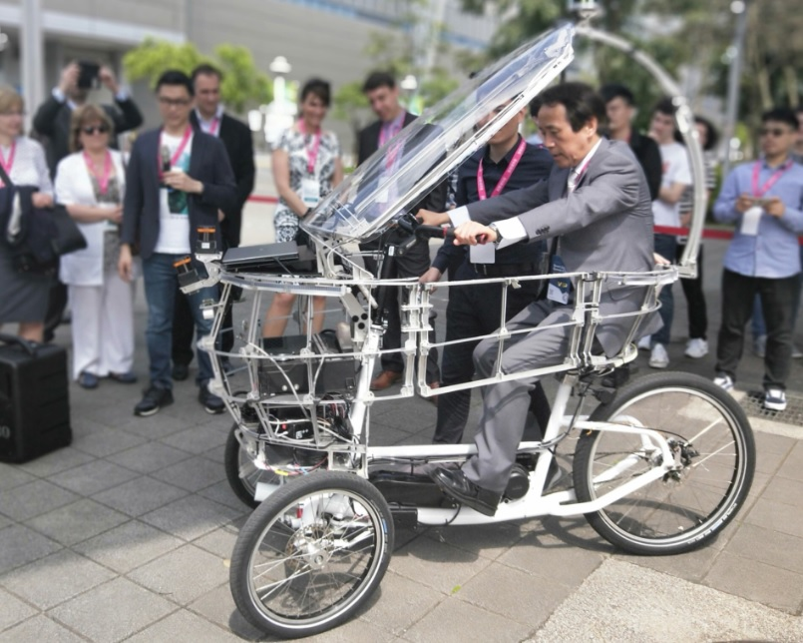
Deputy Mayor Charles Lin trying out the PEV (persuasive electric vehicle) self-driving tricycle

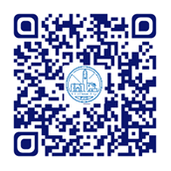
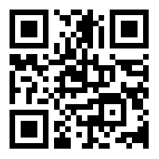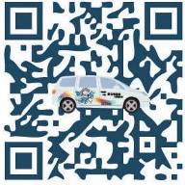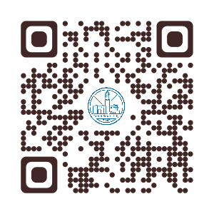
圖1 以電腦瀏覽世大運官網
圖1 以電腦瑩幕瀏覽世大運官網
pay.taipei 資訊局FB 市民數位免費訓練FB PMO FB 臺北智慧城市網站

pay.taipei
Department of Information Technology FB
Citizen digital free training FB
Project Management Office FB
Taipei smart citywebsite

